AWS S3 Lifycycle Policy

1. AWS Life cycle
2. Create a public bucket and object in that bucket and make it public

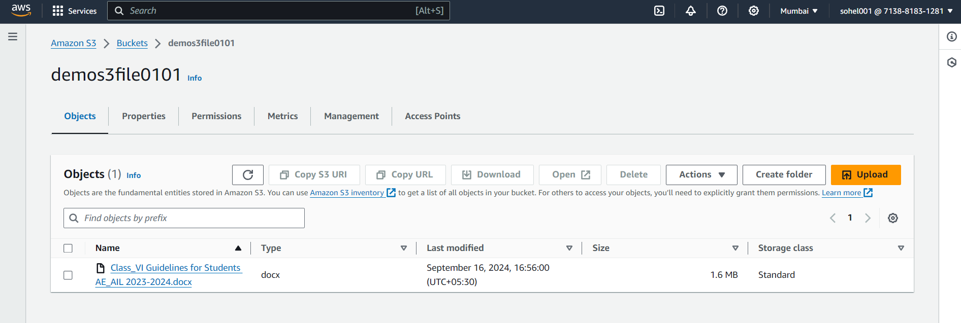

1. Creating rule and apply S3 life cycle policy to bucket

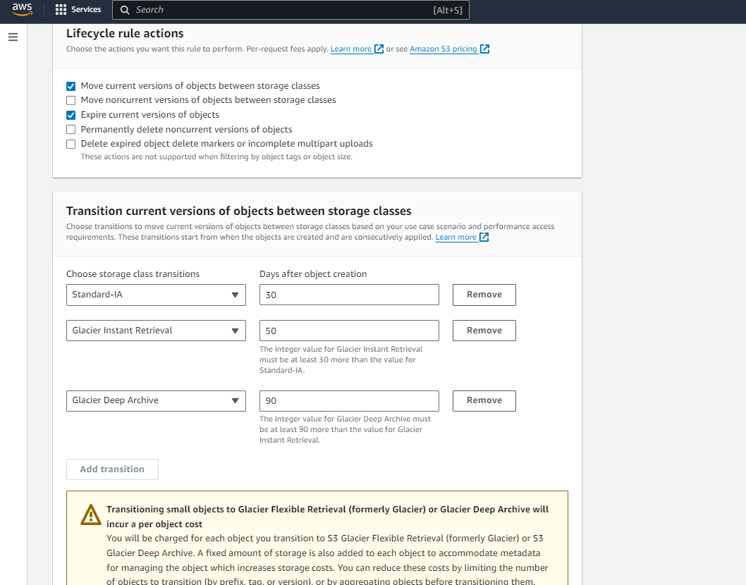

1. S3 Life cycle configuration

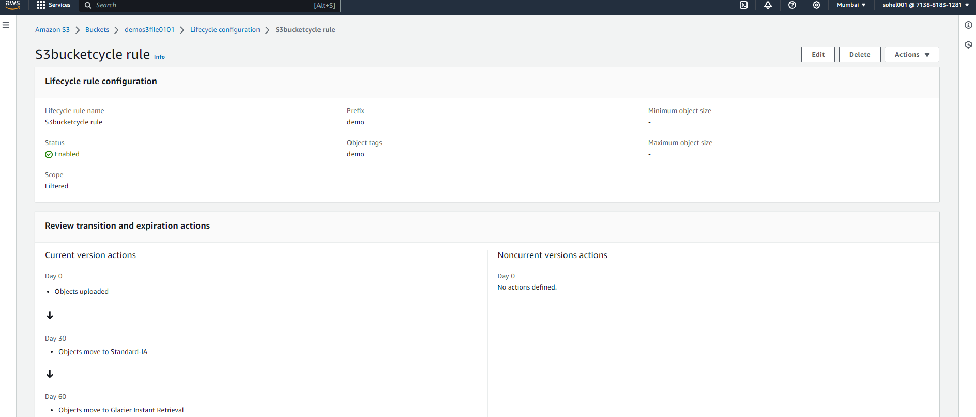

1. **S3 Versioning**
2. Enable S3 versioning of bucket

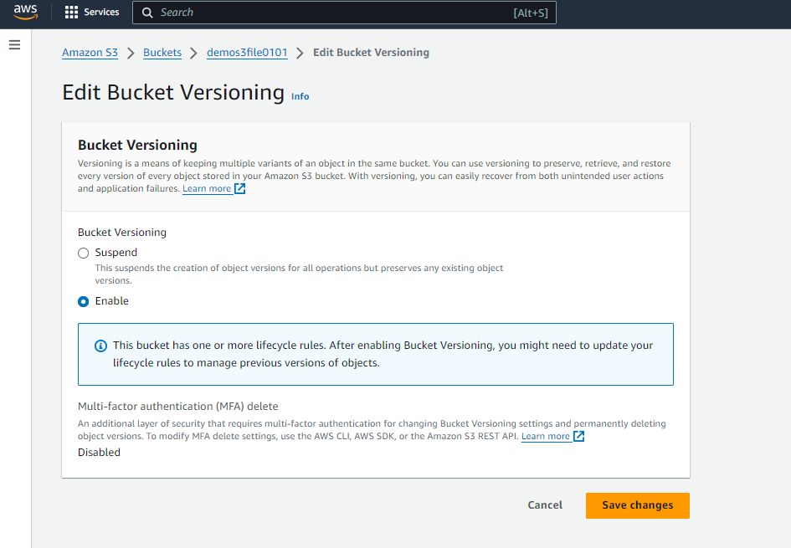

1. After adding file below are version rule created

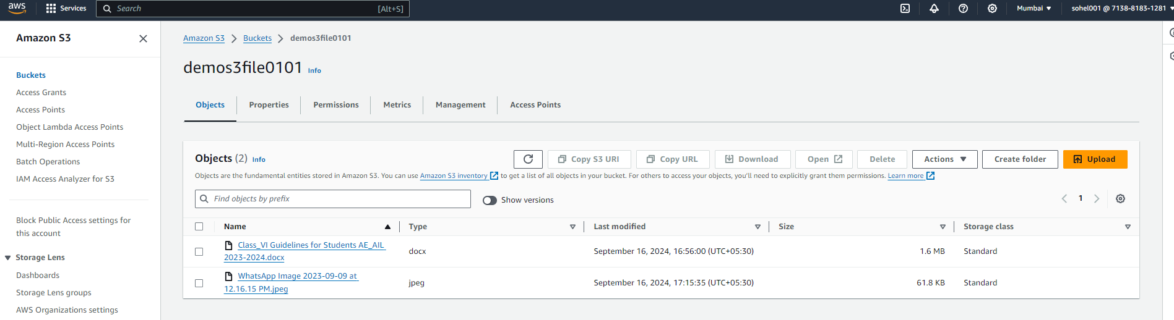

1. **Cross region replication**
2. Create one more bucket in other region

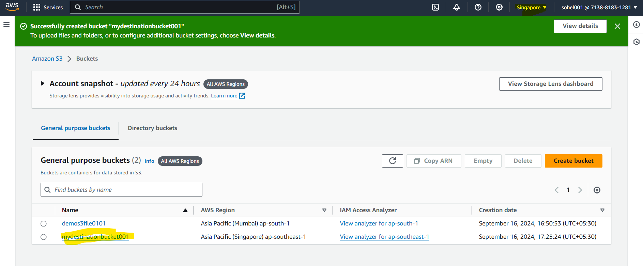

1. Added in destination bucket

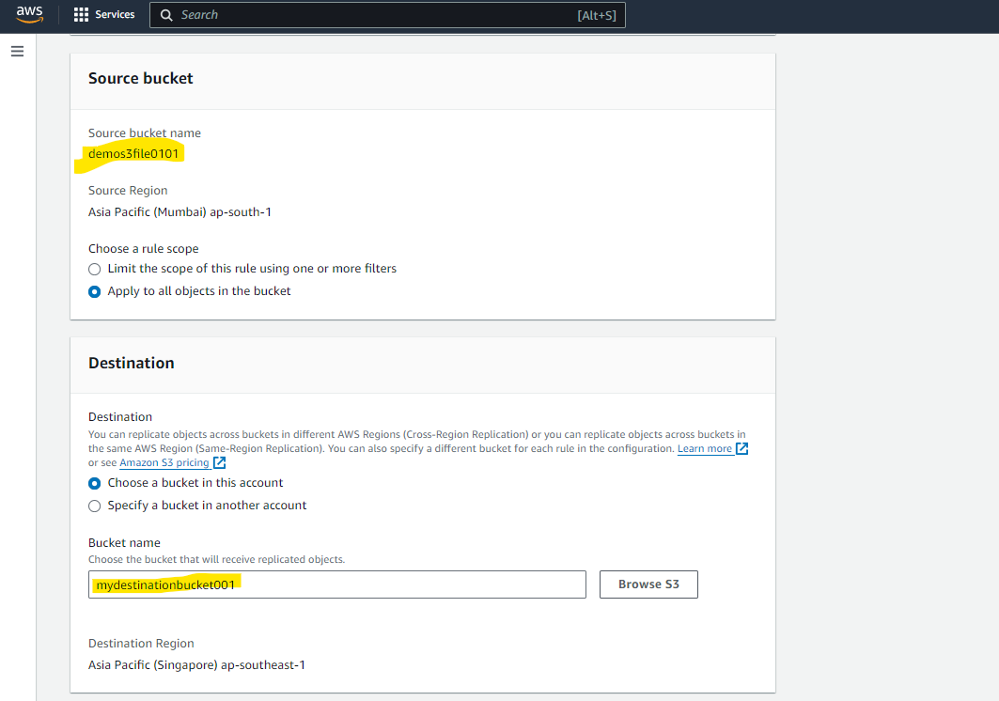

1. After adding new file go in the desitnation bucket

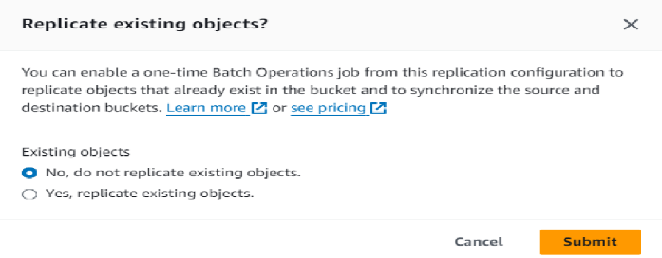

1. To confugure replication rule

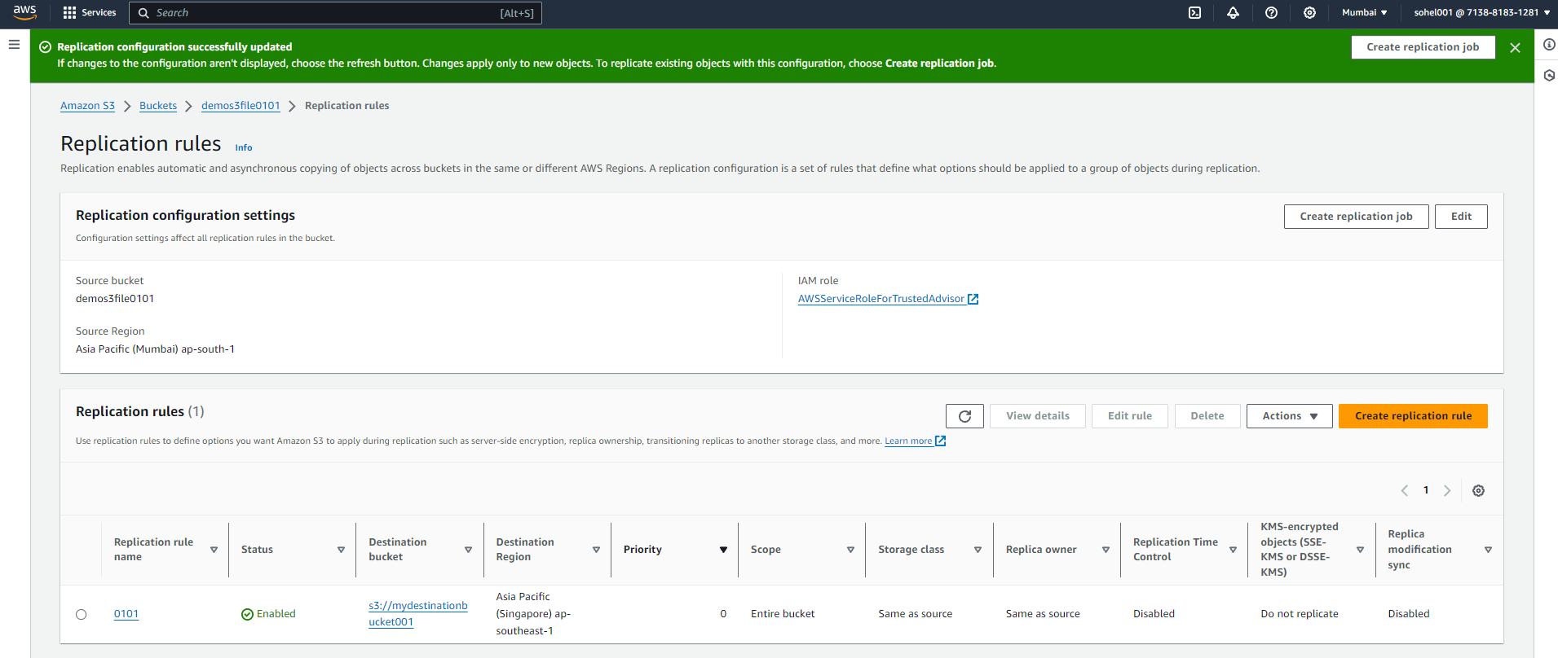

1. Upload new file in source bucket

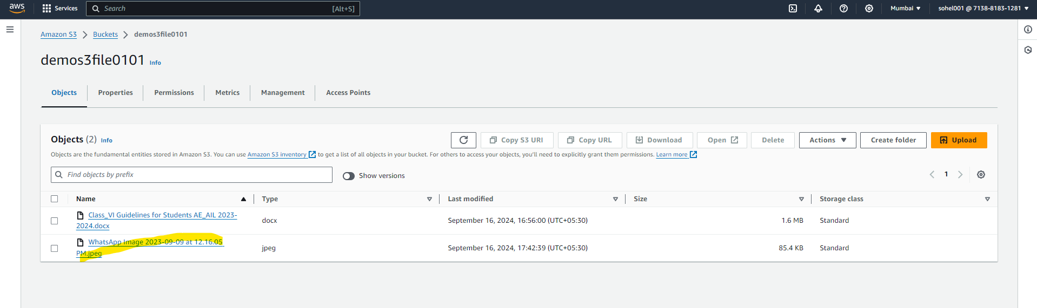

1. We can see its present in the destination bucket

